BHARAT KUMAR 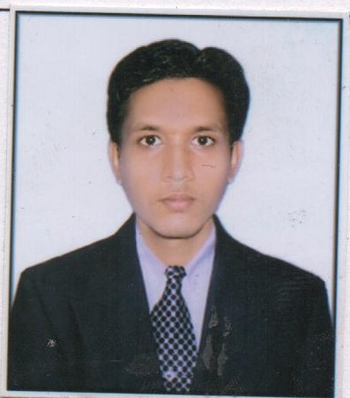
E-Mail: bharatronic9@gmail.com
Contact: +91-9852671888

SENIOR MANAGEMENT PROFESSIONAL: Nearly 3 years of rich experience; targeting assignments as Team Lead in
After- Sales | Service Operations | Channel Management
Industry Preference: Automobile/ Generators

PROFILE SUMMARY

- Highly successful in ensuring delivery of quality services to support customer's business needs & achieving continued high customer satisfaction from all operational users for services
- Skilled in regulating customers service, general administration and customer satisfaction while developing campaigns to encourage owners to choose the shop for their next service or repair
- Proven excellence in the implementation of service policies and processes for maximizing revenues
- Expertise in providing the earliest possible notification of potential service disruption or degradation and recommending procedures to develop business rationale and benefits of proposed changes
- Proficient in ensuring sufficient continued communication and transparency & contractual visibility to both parties along with continuous evaluation of quality, cost & delivery covering service level agreement
- A keen communicator with honed interpersonal, problem solving and analytical skills

CORE COMPETENCIES

Training and Development Strategic Planning Capability building
After-Sales Services Service Operations Customer Service Operations
Dealer Management Business Development MIS & Documentation
Workshop Management Spare Part Management Warranty Management

ORGANIZATIONAL EXPERIENCE

Narayan And Komalam Pvt Ltd(Suzuki Motorcycle)
Service-Bihar(Patna) June’’ 2nd-2014 –present
Role:
- Implemented dealerships service processes/ Quality index
- Gathering Field technical feedback information (FTIR)
- Initiated regular meeting with Service Engineers to improve Customer Satisfaction level & dealer profitability sources.
- Promoted revenue generation by means of increased post warranty/ paid reportings & extended warranty
- Conducted technical training for dealer staff and service activities, capability building
- Conducted Free Service Camp’s and worked for dealer profitability sources.
- Implementations of DMS & CRM activities.

IT SKILLS

- Microsoft Office/ Internet Applications
EDUCATION

2015 Persuing MBA ,(sales & MKT), from Sikkim Manipal University- corresponding.
2014 B.Tech (Mechanical engg), from U.P.T.U (UP) with 66% marks.
2007 Metriculation from B.S.E.B with 67% marks.

PERSONAL DETAILS

Date of Birth: 19/01/1993
Languages Known: Hindi & English.
Address: Chandpur Bela Azad Lane Gali No-2, Dopulwa Patna, P.O-G.P.O, P.S- Jakkanpur,
Pin Code-800001

